

**Question:**

Implement the Inorder Traversal of the Tree….?

**Answer:**

TreeNode.java

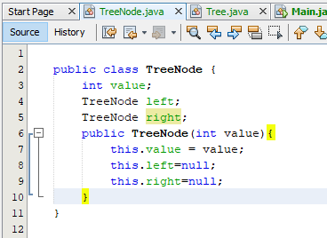

Main.java

Tree.java:

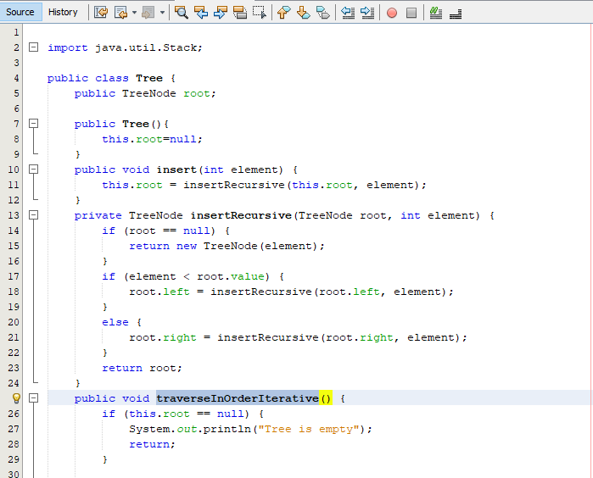

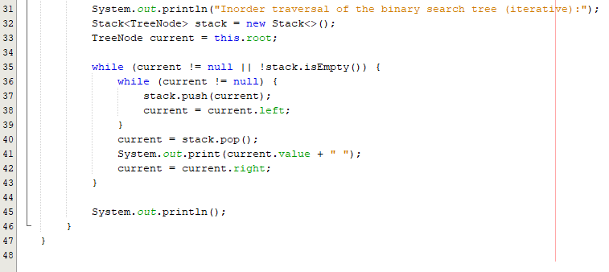

Control Flow Graph:

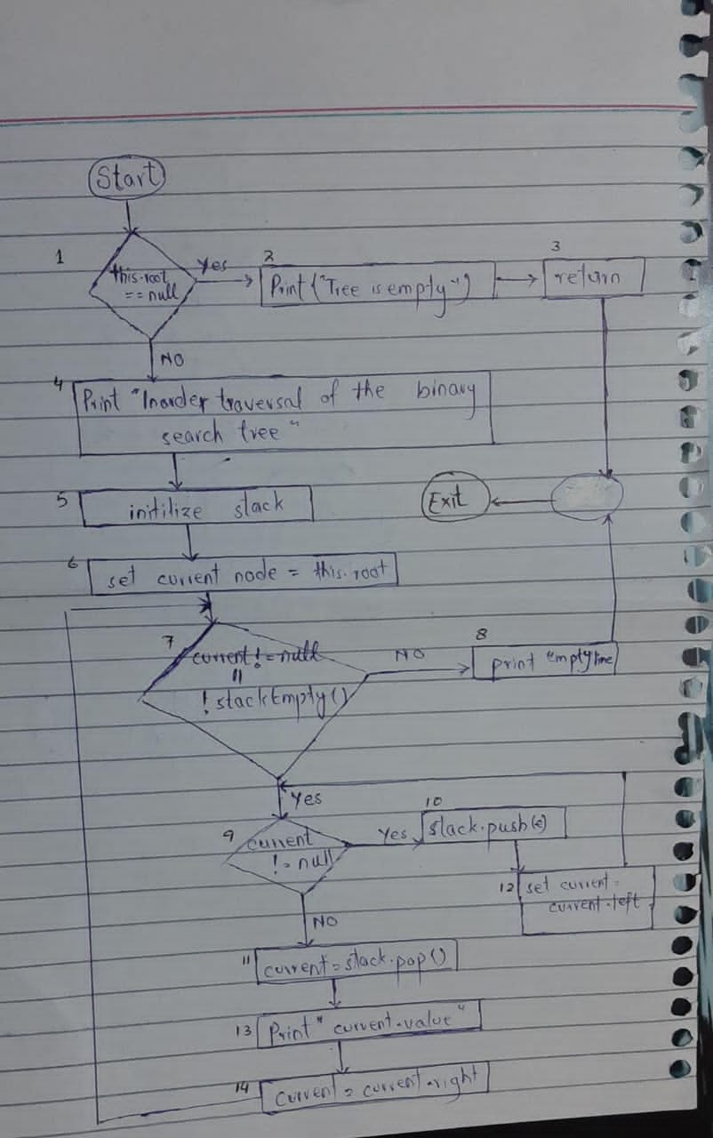

**Paths:**

Path 1 🡪 1, 2, 3.

Path 2 🡪 1, 4, 5, 6, 7, 8.

Path 3 🡪 1,4,5,6,7,9,10,12,9,11,13,14,7,8.

Path 4 🡪 1,4,5,6,7,9,11,13,14,7,8.

**Test Cases:**

|  |  |  |  |  |  |
| --- | --- | --- | --- | --- | --- |
| Test Case ID | Description | Input Data | Expected Output | Actual Output | Status |
| TC_001 | The root of the tree is “null” (i.e the tree is empty) |  | Display Msg: “Tree is Empty” | Display Msg: “Tree is empty” | Pass |
| TC_002 | The stack has some element (i.e node) in it. |  | Display Msg: “Inorder traversal of the binary search tree (iterative):”  and an empty line is printed. |  |  |
| TC_003 | The tree has some elements in it. Now when this method will be called the elements will be printed. |  | Display Msg: “Inorder traversal of the binary search tree (iterative):”  and all the elements of the tree. | Display Msg: “Inorder traversal of the binary search tree (iterative):”  and all the elements of the tree. | Pass |
| TC_004 | Current is equal to null but the stack is not empty and has some element.. |  | Display Msg: “Inorder traversal of the binary search tree (iterative):” and one element that was in stack is printed. | Display Msg: “Inorder traversal of the binary search tree (iterative):” and one element that was in stack is printed. | Pass |